# Lab 5: Data

## Objectives

*  Add data
*  Display the data

## Steps

### Add data

1. **Download** the code snippets, data, and images needed for the labs by **following these steps**.
   1. **Unpack** the snip repository archive in this folder.
2. Open File Explorer (Windows) or Finder (Mac).
3. **Copy** the snip-master\labs\js\snippets\lab05\assets directory (including the assets directory) into the keeptrack\public directory.
4. **Copy** the files snip-master\labs\js\snippets\lab05\MockProjects.js and snip-master\labs\js\snippets\lab05\Project.js into the keeptrack\src\projects directory.

### Display the data

1. Open the file src\projects\ProjectsPage.js.
2. Use JSON.stringify() to output the MOCK_PROJECTS array from MockProjects.js in the render method of the component.

**TIPS:**

* + React components can only return one root element so you will need to wrap the <h1> and <pre> tags in a React Fragement <></>.
  + Wrapping output in a HTML <pre></pre> (preformatted) tag retains whitespace.
  + To switch to JavaScript in JSX use { }
  + JSON.stringify(MOCK_PROJECTS, null, ' ')'s third argument is used to insert white space into the output JSON string for readability purposes. The second argument is a replacer function so we can pass null because we don't need to replace anything.

### Solution

#### src\projects\ProjectsPage.js

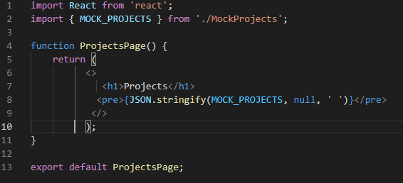

### ✔ You have completed Lab 5